

# DECLARATION

I declare to The State University of Zanzibar that is my own original work done within the period of registration and that it has neither been submitted nor being submitted in any other institute or university.

Moh’d Mshimba Seif. Date

………………………… ……./……/…………..

The above declaration is confirmed by:

Dr. Haji Ali Haji Date

………………………… ……./……/…………..

(Supervisor)

# AKNOWLEDGEMENT

First of all, we should like to thanks Allah for give us good health on that time. Then we should like to thank all dear teachers to participate on that project from day one up to now.

Second, we are grateful to many individuals who contributed to Zanzibar Bureau Standards and Zanzibar Food and Drug Agency, and we wish to thank all of them for their contributions to the completion of this system;

Dr. Haji Ali Haji, the State University of Zanzibar, Department of Computer Science (Project Supervisor).

Mr. Hamiar: The State University of Zanzibar, Department of Computer Science (Project coordinator).

Mr. Masoud Mmanga: The State University of Zanzibar, Department of Computer Science (Website Lecturer) Finally, we also appreciate the output of the entire group member since we have fully cooperating and giving suggestions during the conduct of the project. Once again, we would like to thank all those who helped in our project. Thanks everyone.

# ABSTRACT

fDI system is one among the web systems that will deal with all aspects of product and drug testing, export and domestic products will be monitored to ensure the safety of human and biodiversity is safe.

In this system we can register products or medicines and check the quality of the product through this web system and finally issue a certificate for all products that were safe in the survey conducted.

To achieve all of these goals, the study will employ case study as a research design, the study will interview product receivers and product inspectors with the aim of getting all the details and remove those challenges that they face in their performance.

This document shows the procedure which used to create this system, source code as well as implementation.

# TABLE OF CONTENT

Contents

DECLARATION ii

AKNOWLEDGEMENT iii

ABSTRACT iv

TABLE OF CONTENT v

TABLE OF FIGURES vii

ABRIVIATIONS viii

CHEPTER 1: INTRODUCTION 1

1.1 DESCRIPTION OF THE PROJECT 1

1.2 PRELIMINARY STUDY AND BRIEF PROBLEM STATEMENT 1

1.3 PROPOSED SOLUTIONS AND SCOPE 1

1.4 MAIN AIM AND SPECIFIC OBJECTIVES 2

1.5 PROJECT BACKGROUND AND MOTIVATION 2

1.6 FEASIBILITY 2

CHAPTER 2: METHODOLOGY 3

2.1. Software development approach (object oriented or structured) 3

2.2. Software development life cycle model (SDLC) 3

2.3. System Architecture 4

2.4. Software development tools 4

CHAPTER 3: REQUIREMENTS ANALYSIS AND MODELING 5

3.1 Requirement determination 5

3.1.1 Information gathering techniques 5

3.1.2 Functional requirement 5

3.2 Requirement Structuring 7

3.2.1 Process Modelling 7

3.2.2 Data Modelling 10

CHAPTER 4: SYSTEM DESIGN 12

4.1. Architectural design 12

4.2. Database Design 13

4.2.1. Relational Model 13

4.2.2. Data Description 14

4.2.3. Data Dictionaries 14

4.3. User Interface Design Sample 19

4.3.1. Forms and Reports 19

4.3.2. Interface design sample 21

CHAPTER 5: SYSTEM IMPLEMENTATION AND TESTING 22

5.1 Technologies 22

5.1.1 Java Code 22

5.1.2 Html Code (Bootstrap) 23

5.1.3 Webservices Code 24

5.1.4 CSS Code 24

5.1.5 Android Code 26

5.1.6 JavaScript 27

5.2 Database implementation 28

5.2.1 Internal Schema of database (database schema) 28

5.3 Testing 29

5.4 User Interfaces 31

5.5 Strength ad Limitation of the system 37

CHAPTER 6: CONCLUSION, RECOMMENDATIONS AND CHALLENGES 38

References 39

# TABLE OF FIGURES

Figure 1:SDLC .............................................................................................................................................. 3

Figure 2: System Architecture ...................................................................................................................... 4

Figure 3: Use Case Current System .............................................................................................................. 7

Figure 4: Proposed User case Diagram ......................................................................................................... 8

Figure 5: Class diagram .............................................................................................................................. 10

Figure 6: Entity relationship diagram ......................................................................................................... 11

Figure 7: Architectural design .................................................................................................................... 12

Figure 8: Relational Model ......................................................................................................................... 13

Figure 9: Registration From ........................................................................................................................ 19

Figure 10: Report Form .............................................................................................................................. 20

Figure 11: Report Form .............................................................................................................................. 21

Figure 12: Database implementation ......................................................................................................... 28

Figure 13: Login Testing .............................................................................................................................. 30

Figure 14: Change Password ....................................................................................................................... 31

Figure 15: User login ................................................................................................................................... 32

Figure 16: Manage Laboratory .................................................................................................................... 32

Figure 17: Sample Records .......................................................................................................................... 33

Figure 18: Register User from ..................................................................................................................... 33

Figure 19: Scanner Input ............................................................................................................................. 35 Figure 20: Scanner output .......................................................................................................................... 36

# ABRIVIATIONS

|  |  |  |
| --- | --- | --- |
| FDI |  | Food and Drug Inspection in Mobile App |
| SUZA |  | The State University of Zanzibar |
| ZFDA |  | Zanzibar Food and Drug Agency |
| ZBS |  | Zanzibar Bureau Standards |
| API |  | Application Programming Interface. |
| DFD |  | Data Flow Diagram. |
| DR. |  | Doctor. |
| PK |  | Primary Key |
| FK |  | Foreign Key |
| ERD |  | Entity Relational Diagram |
| SDLC |  | Software development life cycle model |
| HTML |  | Hypertext Markup Language |
| S/N |  | Serial Numbers |
|  |  |  |

# CHEPTER 1: INTRODUCTION

## 1.1 DESCRIPTION OF THE PROJECT

Food and Drug Inspection in Mobile App using Barcode is a system that under Zanzibar government institution that works to prepare standards, manage, promote the use of standards that imported from external and internal countries to the ZBS and enforce standards in order to ensure health and safety of the consumers as well as protecting environment while promoting favorable manufacturing and trade based on quality of goods and services.

## 1.2 PRELIMINARY STUDY AND BRIEF PROBLEM STATEMENT

Currently Zanzibar Bureau of Standards (ZBS) there is a challenge of have no system an institution that has a lot of problems due to all their activities they do in manual process, all research records are done using paper, from the beginning where arrival from the port to the ZBS and store its details by using paperwork.

This may lead to delay the product being tested and lack of means to track product quality through technologies.

## 1.3 PROPOSED SOLUTIONS AND SCOPE

**Proposed Solutions**

The proposed system will be an automated by develop a computerized system that will record the information of products both from external to internal and internal product directed to Zanzibar Bureau Standards System (ZBS).

It also keeps track of quantity and time of the product, enters or leaves in the ZBS and track the one who was responsible to receive, inspect and assign the products.

The proposed system will track the product detail by checking quality of the product contained within using Bar Code readers.

**The Scope**

The scope of this project includes port data for products imported from inside and outside of Zanzibar, ZBS located at Amani Zanzibar and ZPDA, the office that who inspect the product contained within the community.

## 1.4 MAIN AIM AND SPECIFIC OBJECTIVES

**Main Objectives**

The main aim of the proposed system is to record information’s in systematically and make product inspections done quickly using barcode readers.

**Specific Objectives**

The specific objectives of this project are: -

* To design the database for Storing Document Information.
* To design the web-based system for communities.
* To design the android application for the inspectors.
* Implementing Database, Web Based system and android Application.
* Integration of Database and Web Based application, android application.

## 1.5 PROJECT BACKGROUND AND MOTIVATION

The currently they have no automatic system that available from ZBS in order for tracking the product and the motivation is I come with the system that will solve this process, those activities will be solved by using this system.

## 1.6 FEASIBILITY

Feasibility study were conducted in organization where requirements were collected at Zanzibar Bureau of Standards and Zanzibar Food and Drug Agency.

The study area of our project is in the Local Communities in Zanzibar where the interview done through it.

* **Technical**: It is visible because the proposed system will be very easy to interact with users and control it.
* **Economic**: In propose system develop we use software that most of them are open sources, such as MySQL which is used to create database and script language is JAVA all of them no need of license when used.
* **Operational**: To implement this project is possible since most of the people have laptop and smart phone, so they can use this system anytime and anywhere if their Internet

# CHAPTER 2: METHODOLOGY

## 2.1. Software development approach (object oriented or structured)

In this project I approach on the Object-Oriented software development because: -

* Its bundle code into a single unit where you can determine the scope of each piece of data.
* The class can inherit attributes and behaviors from another class, you are able to reuse more code.
* One class can be used to create many objects, all from the same flexible piece of code.

## 2.2. Software development life cycle model (SDLC)

We appreciate to use agile model because this model allows changes when they are required (Time to time changes).

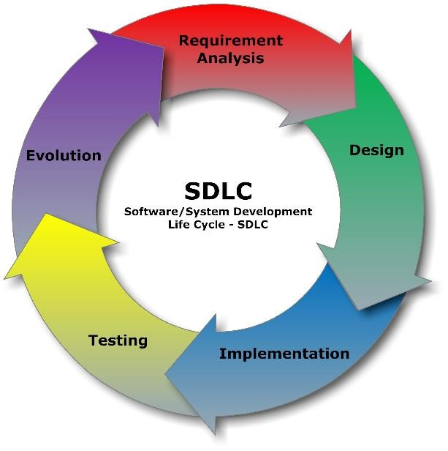

*Figure 1:SDLC*

## 2.3. System Architecture

The system architecture is Two tier Architecture, the Client side can access the system and get notification from the Server side and the Server side can send the result to the customers.

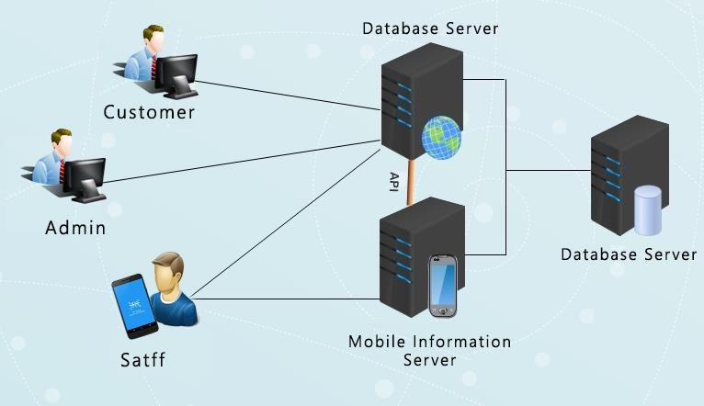

*Figure 2: System Architecture*

## 2.4. Software development tools

In this project we are going to use various software development tools concerning the front-end view and back-end view as following: -

Front-end – Java-Jsp, Android Studio Backend - JAVA

# CHAPTER 3: REQUIREMENTS ANALYSIS AND MODELING

## 3.1 Requirement determination

In a feasibility study period, I have spent a lot of time for studying the function of the existing system and how it operates at the department, purposely to get the data in accuracy manner.

#### 3.1.1 Information gathering techniques

While gathering requirement I have used different techniques for collecting the needed requirements. These techniques are as followed:

* Interviews: interview was carried out through means of questions and answers with the client to determine what requirement is needed for the new system to be developed.
* Observation: also, an observation was done in order to determine the requirements by looking the processes that happen in the current system.
* Existing system reviews: an observation was also carried out to review some of the existing that are similar to the proposed system, in order to determine how the new system can be implemented.

#### 3.1.2 Functional requirement

This proposed project describes detailed and specific requirement of the project. It will also include the function requirement covering the functionalities expected by the users, a complete specification which describes all the functionalities of the system and non-functional requirements such as reliability, portability, accessibility, maintainability and usability.

*Functional Requirements*

1. The system should allow customer be register.
2. The system should allow Customer to view his/her product result.
3. The system should allow sample Receiver to register product information in the database.
4. The system should allow Distributer splitting task to the related user.
5. The system should allow Distributer to supply product to the related analyzers. vi. The system should allow inspector to inspects product using mobile phone.
6. The system should allow Inspector to provide inspection result.
7. The system should allow to generate certificate for successes inspected product ix. The mobile app should allow scanning barcode in order to generate results.

*Non-Functional Requirements*

The FDI system shall allow notification to user when activity succussed.

*Other non-functional requirements*

**Performance Requirements**: This system is expected to have good performance and fast response time. When a user login, fill the product registration form, the system is expected to take not more than 20 seconds to respond.

**Safety Requirements**: For the safety of all data, the system will save the data of each product to the database once he/she submit. If the system crash, the system is expected to continue working fine when it is restarted and all the data that were saved before the crash will not be affected. **Security Requirements**: This system will be secured for all data. The system will secure all users passwords with encryption, so that nobody else will be able to know the password. Also, this system will implement high level of data privacy. Only allow and authenticated users will be able to access the particular data on a particular time.

## 3.2 Requirement Structuring

#### 3.2.1 Process Modelling

*3.2.1.1 Use case diagram to illustrate how current system is implemented.*

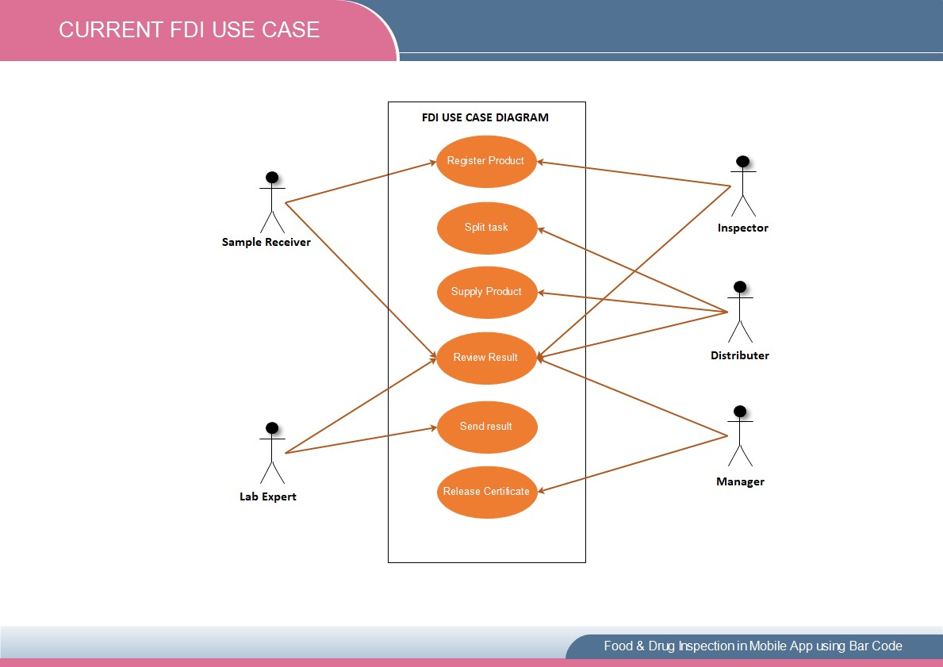

##### Figure 3: Use Case Current System

*3.2.1.2 Use Case model (User case Diagram and Use case Description).*

Proposed User case Diagram

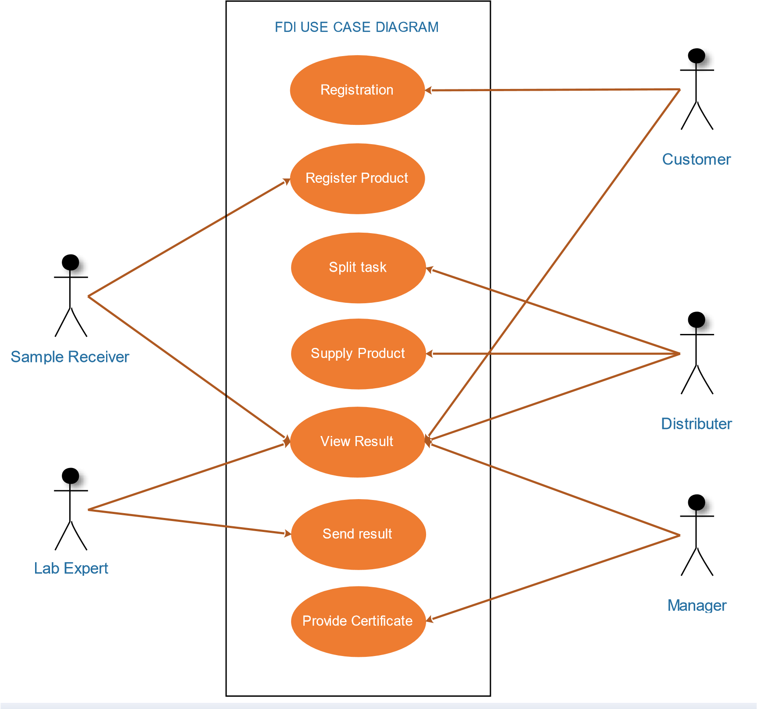

##### Figure 4: Proposed User case Diagram

Use case Description

IDENTIFIED ACTORS

|  |  |  |
| --- | --- | --- |
| **S/N** | **ACTORS** | **DESCRIPTIONS** |
| 1 | Customer | This is a person who sends his product to the factory (zbs) for the purpose of getting quality on its products.  But also this customer can get a result on his products being tested. |
| 2 | Distributer | This person who is responsible for breaking and distributing the task for each product should go to the relevant laboratory for the purpose of going to be examined. |
| 3 | Sample  Receiver | This is a person who is responsible registration of products and making sure that all products are delivered to the factory for the purpose of going to be tested for the quality of the product.  This customer can review the result of the scanned product. |
| 4 | Lab Expert | This is a laboratory person who is responsible for inspecting all product delivered to the laboratory.  But he is also responsible for providing product results based on the inspection he has performed for the relevant products. |
| 5 | Manager | This is the top leader in the system who is responsible for allowing the product to obtain a certificate and be included in the marketing or rejection. |

#### 3.2.2 Data Modelling

*3.2.2.1 Class diagram*

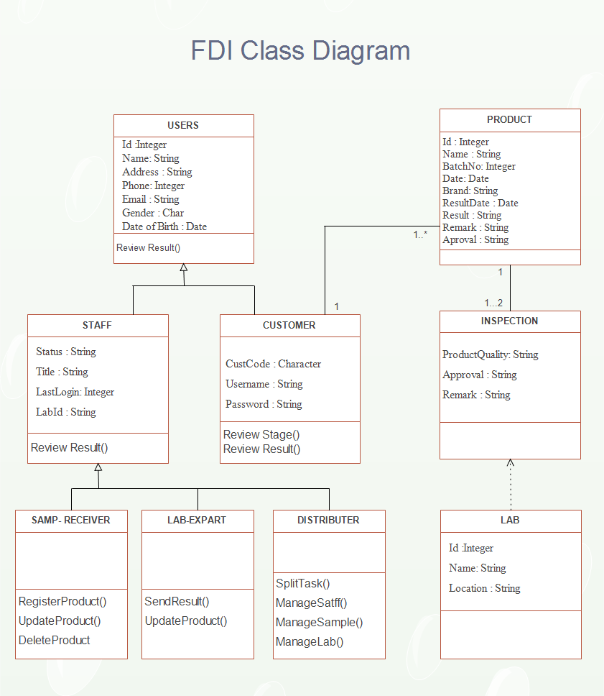

##### Figure 5: Class diagram

*3.2.2.2 Entity relationship diagram*

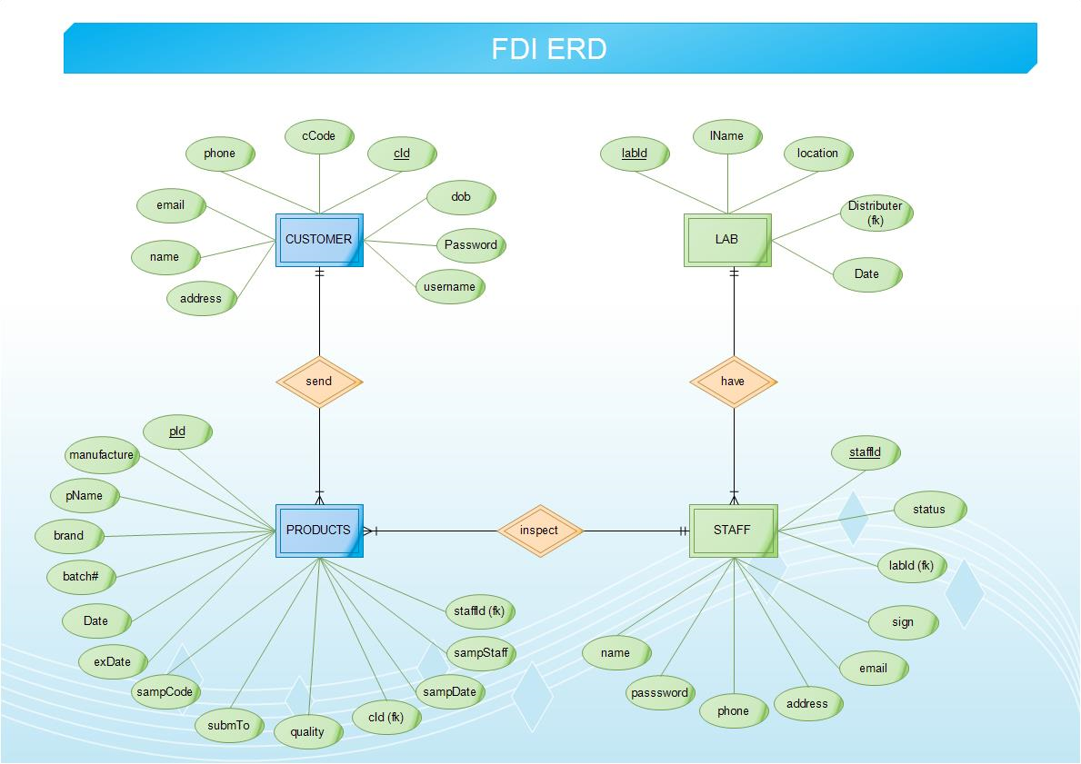

##### Figure 6: Entity relationship diagram

# CHAPTER 4: SYSTEM DESIGN

## 4.1. Architectural design

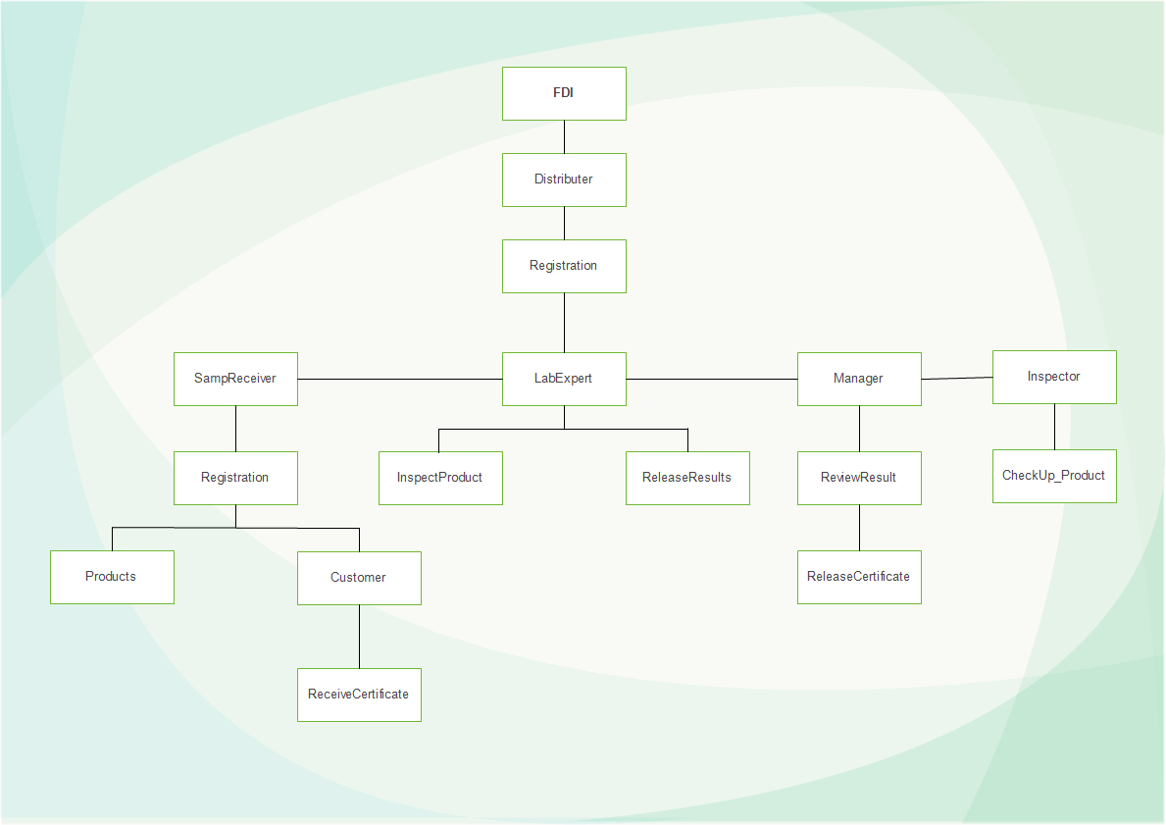

##### Figure 7: Architectural design

## 4.2. Database Design

#### 4.2.1. Relational Model

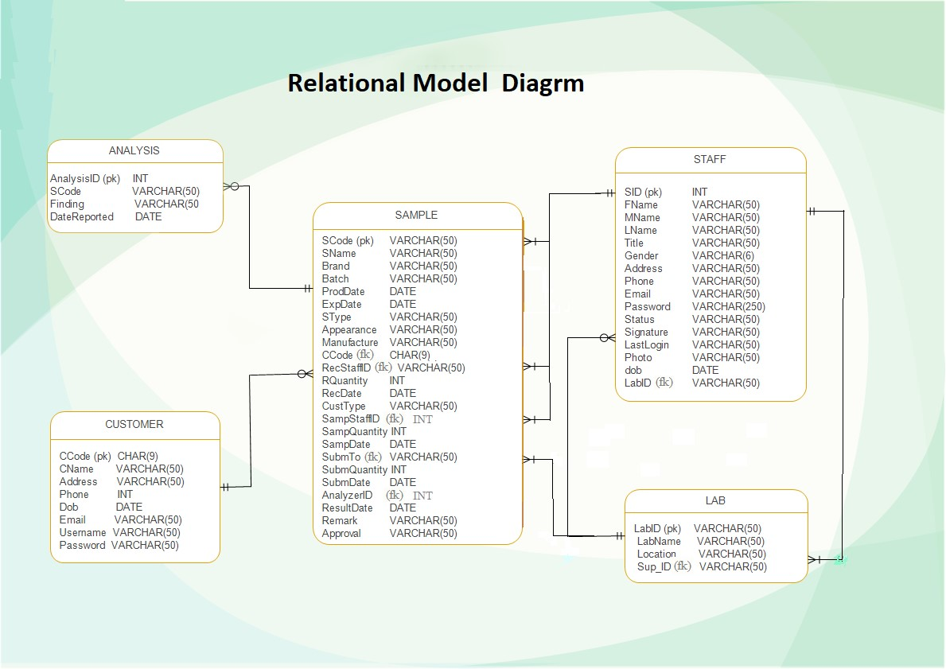

##### Figure 8: Relational Model

#### 4.2.2. Data Description

**CUSTOMER**: The attributes of this table are CCode (PK), CName, Address, Phone, dob, Email, Username, Password. The customer table are used to store customer data for the purpose of knowing who owns the products.

**LAB**: The attributes of this table are LabID (PK), LabName, Location, Sup_ID. The LAB table are used to store record of laboratory, this table are interconnected with staff table due to the lab being supervised by staff.

**LOGIN** LoginID (PK), Username, Password, CCode, SID, Status

**STAFF**: SID (PK), FName, MName, LName, Title, Gender, Address, Phone, Email, Password, Status, Signature, LastLogin, Photo, Doob, LabID.

**ANALYSIS:** Analyzer, SCode, Water, Protein, Sugar, Calcium, Sodium, Zink, Energy, Caffeine, Starch, Alcohol, FatyAcid.

**APPOINTDATE:** AppID (PK), CommingDate, OptionalDate, CCode, SampType

**SAMPLE:** SCode (PK), SName, Brand, Batch, ProdDate, ExpDate, SType, Appearance, Manufacture, CCode, RecStaffID, RQuantity, RecDate, CustType, SampStaffID, SampQuantity, SampDate, SubmTo, SubmQuantity, SubmDate, AnalyzerID, ResultDate, Remark, Approval.

#### 4.2.3. Data Dictionaries

Table Name: The name for the Table.

Column Name: The predefined name for the column.

Description: A detailed description of the contents and purpose for the column Data Type & Size: The predefined characteristics for the column.

**Table Name: Customer**

|  |  |  |  |
| --- | --- | --- | --- |
| **S/N** | **COLUMN**  **NAME** | **DESCRIPTION** | **DATA TYPE** |
| 1 | CCode | A unique identification of users table | Char (9) |
| 2 | CName | Names of customers (First, middle and last). | Varchar (50) |
| 3 | Address | The location of customer is live. | Varchar (50) |
| 4 | Phone | The phone number of customers | Int |
| 5 | Dob | The date of birth of customer | Date |
| 6 | Email | The email address of customer for notification | Varchar (50) |
| 7 | Username | The password that users use for login | Varchar (50) |
| 8 | Password | The encrypted password of customer | Varchar (250) |

**Table Name: Lab**

|  |  |  |  |
| --- | --- | --- | --- |
| **S/N** | **COLUMN**  **NAME** | **DESCRIPTION** | **DATA TYPE** |
| 1 | LabID | A unique identification of user’s table. | Varchar (50) |
| 2 | LabName | The name of laboratory where product inspected | Varchar (50) |
| 3 | Location | The location of LAB, where are allocated | Varchar (50) |
| 4 | Sup_ID | Foreign key that makes relation from Staff table | Varchar (50) |

**Table Name: Analysis**

|  |  |  |  |
| --- | --- | --- | --- |
| **S/N** | **COLUMN**  **NAME** | **DESCRIPTION** | **DATA**  **TYPE** |
| 1 | Analyzer | A unique identification number of user’s table. | Int |
| 2 | SCode | Foreign key that makes relation from Sample table | Varchar (50) |
| 3 | Water | The required water is needed from the products | Varchar (50) |
| 4 | Protein | The required Protein is needed from the products | Varchar (50) |
| 5 | Calcium | The required Calcium is needed from the products | Varchar (50) |
| 6 | Sodium | The required Sodium is needed from the products | Varchar (50) |
| 7 | Zink | The required Zink is needed from the products | Varchar (50) |
| 8 | Energy | The required Energy is needed from the products | Varchar (50) |
| 9 | Caffein | The required Caffein is needed from the products | Varchar (50) |
| 10 | Starch | The required Starch is needed from the products | Varchar (50) |
| 11 | Alkohol | The required Alkohol is needed from the products | Varchar (50) |
| 12 | FatyAcid | The required FatyAcid is needed from the products | Varchar (50) |

**Table Name: Staff**

|  |  |  |  |
| --- | --- | --- | --- |
| **S/N** | **COLUMN**  **NAME** | **DESCRIPTION** | **DATA TYPE** |
| 1 | SID | A unique identification of user’s table. | Int |
| 2 | FName | The first name of staff | Varchar (50) |
| 3 | MName | The middle name of staff | Varchar (50) |
| 4 | LName | The last name of staff | Varchar (50) |
| 5 | Title | The rank(status) of staff | Varchar (50) |
| 6 | Gender | The gender type of staff. | Char (6) |
| 7 | Address | The location of staff is live. | Varchar (50) |
| 8 | Phone | The phone number of staffs | Int |
| 9 | Email | The email address of staff for notification | Varchar (50) |
| 10 | Status | The classification (type) of staff | Varchar (50) |
| 11 | Signature | The signature of manager for certificate | Varchar (50) |
| 12 | LastLogin | The last day of staff login from the system | Varchar (50) |
| 13 | Photo | Profile picture of staff | Varchar (50) |
| 14 | Dob | The date of birth of Staff | Date |
| 15 | LabID | Foreign key that makes relation from LAB table | Varchar (50) |

**Table Name: Sample**

|  |  |  |  |
| --- | --- | --- | --- |
| **S/N** | **COLUMN**  **NAME** | **DESCRIPTION** | **DATA**  **TYPE** |
| 1 | SCode | A unique identification of sample table. | Varchar (50) |
| 2 | SName | The name of product | Varchar (50) |
| 3 | Brand | The symbol of products | Varchar (50) |
| 4 | Batch | The number of products | Varchar (50) |
| 5 | ProdDate | The receiving date of the product | Date |
| 6 | ExpDate | The end of date of product to used | Date |
| 7 | SType | The type(sample) of product | Varchar (50) |
| 8 | ResultDate | The result date of product ware released | Date |
| 9 | Manufacture | The manufacture of the products (owners) | Varchar (50) |
| 10 | CCode | Foreign key that makes relation from Customer | Char (9) |
| 11 | Approval | The acceptance and rejected of the product | Varchar (50) |
| 12 | RQuantity | The number of quantities were received | Int |
| 13 | RecDate | Receiving date of product to the lab | Date |
| 14 | CustType | The type of Customer in who bring their product | Varchar (50) |
| 15 | Remark | The failure and passes of product during tested | Varchar (50) |
| 16 | SampQuantity | The quantity of product is received | Int |
| 17 | SampDate | The date on which the product has been inspected | Date |
| 18 | SubmTo | Foreign key that makes relation from LAB table | Varchar (50) |
| 19 | SubmDate | The date of product is submitted to the lab | Date |
| 20 | AnalyzerID | Foreign key that makes relation from STAFF table | Int |

**Table Name: Login**

|  |  |  |  |
| --- | --- | --- | --- |
| S/N | COLUMN  NAME | DESCRIPTION | DATA  TYPE |
| 1 | LoginID | Unique identification number of Login table. | Int |
| 2 | Username | The username credential that use user when login | Varchar (50) |
| 3 | Password | The encrypted password of staff | Varchar (50) |
| 4 | CCode | Foreign key that makes relation from Sample table | Varchar (50) |
| 5 | SID | Foreign key that makes relation from Staff table | Varchar (50) |
| 6 | Status | The status of user that define role of user. | Varchar (50) |

## 4.3. User Interface Design Sample

#### 4.3.1. Forms and Reports

Registration From Sample

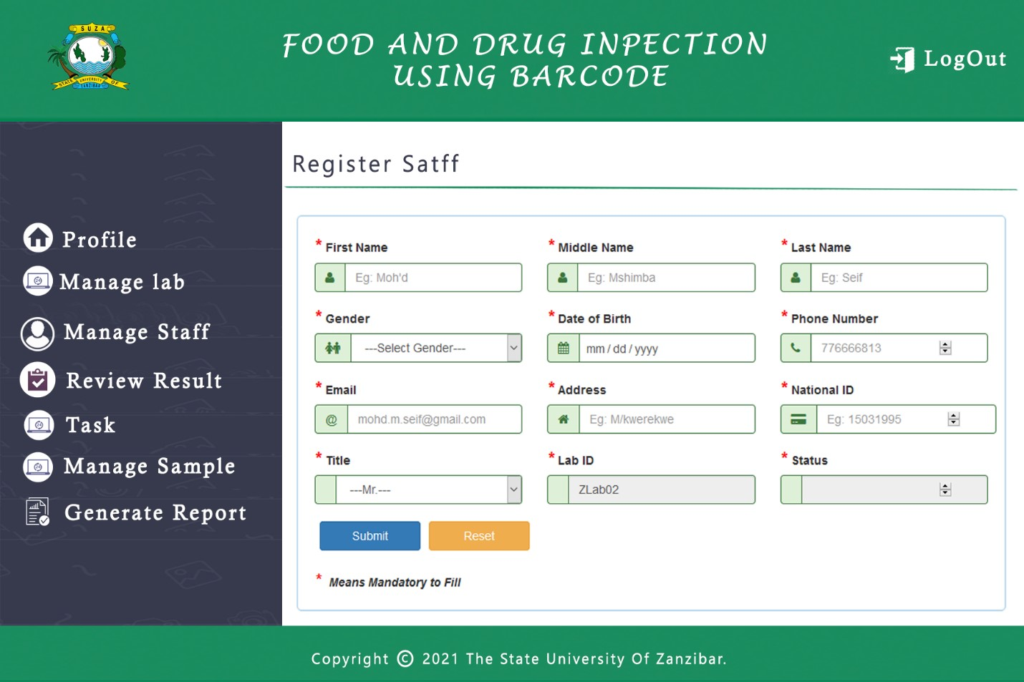

##### Figure 9: Registration From

Report Form Sample

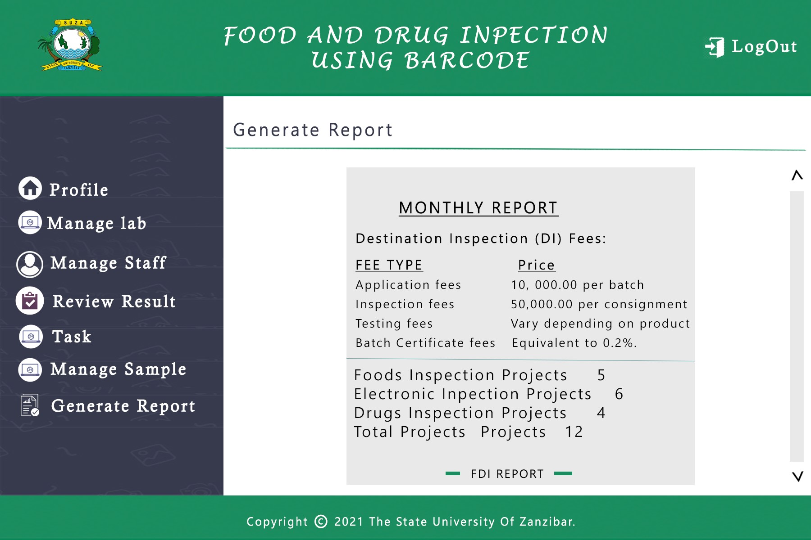

##### Figure 10: Report Form

#### 4.3.2. Interface design sample

Login Form

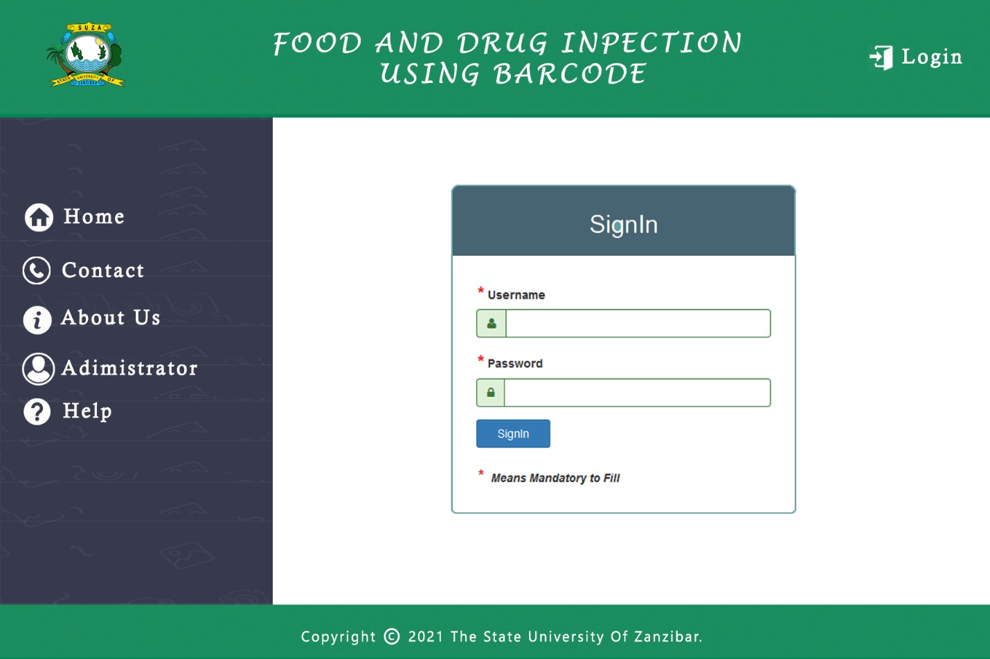

*Figure 11: Report Form*

# CHAPTER 5: SYSTEM IMPLEMENTATION AND TESTING

## 5.1 Technologies

In this project we use various technology such as JAVA, HTML, WEBSERVICES, CSS, Android Studio and MySQL.

#### 5.1.1 Java Code

JAVA: This is a high-level, class-based, object-oriented programming language that is a server-side language for backend development of this project.

**package** loginVar; **public** **cl**loginVariable { **private** **int** LoginID; **private** String username, CCode;

**public** loginVariable () {

**super** ();

}

**public** loginVariable (**int** loginID, String username, String cCode,

String password) {

**super** ();

LoginID = loginID; **this**.username = username; CCode = cCode; **this**.password = password;

SID = sID;

Status = status;

}

**public** **int** getLoginID() { **return** LoginID;

}

**public** **void** setLoginID(**int** loginID) {

LoginID = loginID;

}

**public** String getUsername() { **return** username;

}

**public** **void** setUsername(String username) {

**this**.username = username;

}

**public** String getCCode() { **return** CCode;

}

**public** **void** setCCode(String cCode) {

CCode = cCode;

}

**public** String getPassword() { **return** password;

}

**public** **void** setPassword(String password) {

**this**.password = password;

}

}

#### 5.1.2 Html Code (Bootstrap)

**HTML:** Hypertext Markup Language provides the structure of the page. The all system uses HTML code as the following: -

<!DOCTYPE html PUBLIC "-//W3C//DTD HTML 4.01 Transitional//EN">

<html>

<head>

<meta name="viewport" content="width=device-width, initial-scale=1.0"/>

<title>FOOD AND DRUG | INSPECTION</title>

</head>

<body style="background-image: url(bootstrap/img/bg.png);">

<div id="container">

<div class="panel-body">

<form action="<%=request.getContextPath()%>/LoginServlet" method="post">

<div class="form-group has-success">

<label class="control-label">Username</label>

<div class="input-group">

<span class="input-group-addon">

</span> <input type="text" name="username">

</div>

</div>

<div class="form-group has-success">

<label class="control-label">Password</label>

<div class="input-group">

<input type="password" name="password">

</div>

</div>

<div class="col-md-12" style="margin-bottom:10px">

<label style="color: red; text-align: center;">

</label>

</div>

<div class="form-group">

<label class="checkbox-inline"> </label>

</div>

<input type="submit" class="btn btn-primary" value="Login Now"/>

<p style="margin: 10px"> Not registered?

<a href="#" data-toggle="modal" data-target="#myModal">

<b>Create New Account</b>

</a>

</p>

<p style="margin: 20px; text-align: center; opacity: 0.5">

Copyright © 2021 | Mohd. M. Seif</p>

</form>

</div> </div>

</body>

</html>

#### 5.1.3 Webservices Code

**Webservices**: It allow various application to talk to each other and share data and services among themselves. Some useful services code used in this system are: -

<%@ page language=*"java"* import=*"net.sf.json.JSONArray"*%>

<%@page import=*"java.sql.DriverManager"*%>

<%@page import=*"java.sql.ResultSet"*%>

<%@page import=*"java.sql.Statement"*%>

<%@page import=*"java.sql.Connection"*%>

<% response.setContentType("application/json");

String ids = request.getParameter("SCode");

%>

<%

Connection connection = **null**;

Statement statement = **null**;

ResultSet resultSet = **null**;

**try** {

connection =

DriverManager.getConnection("jdbc:mysql://localhost:3306/FINAL", "root", ""); statement = connection.createStatement();

String sql = "SELECT * FROM sample WHERE SCode='" + ids + "'";

resultSet = statement.executeQuery(sql);

**while** (resultSet.next()) {

%>

{

"SCode":"<%=resultSet.getString("SCode")%>",

"SName":"<%=resultSet.getString("SName")%>",

"Batch":"<%=resultSet.getString("Batch")%>",

"ProdDate":"<%=resultSet.getString("ProdDate")%>",

"ExpDate":"<%=resultSet.getString("ExpDate")%>",

"Manufacture":"<%=resultSet.getString("Manufacture")%>"

}

<%

}

} **catch** (Exception e) {

e.printStackTrace();

}

%>

#### 5.1.4 CSS Code

**CSS:** Cascade Style Sheet are technology for build web pages, all most CSS are used in all page such to decorate, style web pages example: -

<style> **body** {

background: *rgb(204, 204, 204)*;

}

*#th*{ text-align:*center*;

}

**ul** **li** **a***:hover*{

text-decoration:*none*;

}

*#dropL*{

color: *#3D5654*;

}

*#dropL:hover*{

|  |  |
| --- | --- |
|  | color:*#000000*; |
| }    *{ | background:*#E3F2F1*; |
|  | list-style: *none*; |
|  | text-decoration: *none*; |
|  | margin: *0*; |
|  | padding: *0*; |
|  | box-sizing: *border-box*; |
| } | font-family: *'Jost',* *sans-serif*; |

**ul***:hover*{ list-style-type:*none*;

}

**page** { background: *white*; display: *block*; margin: *0 auto*; margin-bottom: *0.5cm*;

box-shadow: *0 0 0.5cm rgba(0, 0, 0, 0.5)*;

} **page**[size="A4"] {

width: *21cm*;

height: *29.7cm*;

}

*#printBtn* { background-color: *#019950*; color: *#fff*; border: *2px solid #f6eb51*; box-shadow: *none*;

margin: *6px*;

}

**ul***#menu* **li** {

display: *inline*;

}

</style>

#### 5.1.5 Android Code

**Android**: This is fastest developer tools for building market-leading apps, some useful code used from this system for building barcode are as follow: -

*<?***xml version="1.0" encoding="utf-8"***?>*

<**RelativeLayout xmlns:android="http://schemas.android.com/apk/res/android" xmlns:app="http://schemas.android.com/apk/res-auto" xmlns:tools="http://schemas.android.com/tools" android:layout_width="match_parent" android:layout_height="match_parent"**

**tools:context="com.example.double_m.afinal.Scan_BarCode"**>

<**ImageView**

**android:layout_width="match_parent" android:layout_height="match_parent" android:src="@drawable/backg" android:scaleType="centerCrop"**/>

<**LinearLayout**

**android:layout_width="match_parent" android:layout_height="match_parent" android:orientation="vertical" android:layout_alignParentBottom="true" android:layout_alignParentLeft="true" android:layout_alignParentStart="true" android:layout_marginBottom="32dp"**>

<**LinearLayout**

**android:id="@+id/header" android:layout_width="match_parent" android:layout_height="match_parent" android:orientation="vertical" android:weightSum="1"**> <**LinearLayout**

**android:layout_width="wrap_content" android:layout_height="wrap_content" android:layout_gravity="center" android:layout_marginTop="250dp" android:orientation="vertical"**>

<**TextView**

**android:layout_width="match_parent" android:layout_height="wrap_content" android:textSize="15dp" android:layout_marginTop="50dp"**

**android:text="i. Click SCAN ME button to Scan BarCode" android:textColor="@android:color/white"** />

<**TextView**

**android:layout_width="match_parent" android:layout_height="wrap_content" android:layout_marginTop="5dp" android:textSize="15dp"**

**android:text="ii. Scan BarCode available in that Product" android:textColor="@android:color/white"** />

<**TextView**

**android:layout_width="match_parent" android:layout_height="wrap_content" android:layout_marginTop="5dp" android:textSize="15dp"**

**android:text="iii. View Result founded from Product" android:textColor="@android:color/white"** />

</**LinearLayout**> <**Button**

**android:id="@+id/buttonScan" android:layout_width="192dp" android:layout_marginTop="65dp" android:layout_height="65dp" android:layout_gravity="center" android:textSize="20dp" android:onClick="goPage2" android:text="SCAN ME"**

**android:textColor="@android:color/white" android:background="@drawable/btn_app"** />

<**ImageView**

**android:id="@+id/imageViewResult" android:layout_width="match_parent" android:layout_height="335dp"** />

</**LinearLayout**>

</**LinearLayout**>

</**RelativeLayout**>

#### 5.1.6 JavaScript(jQuery)

**JAVASCRIPT:** JavaScript was designed to add interactivity to HTML pages JavaScript is a scripting language, JavaScript programs are run by an interpreter built into the user's web browser (not on the server) is for the formatting side of the Web.

<script type=*"text/javascript"*> **function** Delete() {

**return** confirm("Are you sure do you want to delete..?");

}

$(document).ready(**function**() { $("#data").dataTable({ dom : 'Bfrtip', buttons : [ { extend : 'pdf',

text : 'Print PDF'

} ]

});

});

**function** printDiv() { **var** divContents = document.getElementById("GFG").innerHTML; **var** a = window.open('', '', 'height=500, width=500'); a.document.write('<html>');

a.document.write('<body>');

a.document.write(divContents);

a.document.write('</body></html>');

a.document.close();

a.print();

}

**var** hamburger = document.querySelector(".hamburger"); **var** wrapper = document.querySelector(".wrapper"); **var** backdrop = document.querySelector(".backdrop");

hamburger.addEventListener("click", **function**() {

wrapper.classList.add("active");

})

backdrop.addEventListener("click", **function**() {

wrapper.classList.remove("active");

})

</script>

## 5.2 Database implementation

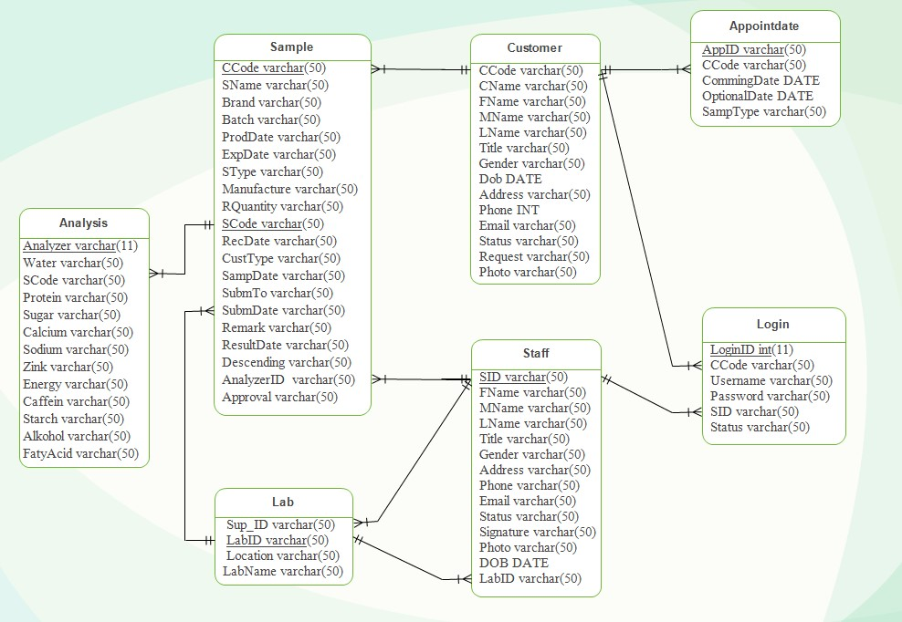

###### *Figure 12: Database implementation*

#### 5.2.1 Internal Schema of database (database schema)

scheme refer to organization data as a blueprint of how the database constructed divided into database table in the case of relational database.

**Analysis** (Analyzer(pk), SCode(fk), Water, Protein, Suga, Calcium, Sodium, Zink, Energy, Caffeine, Starch, Alcohol, FatyAcid).

**Sample** (SCode(pk), SName, Brand, Batch, ProdDate, ExpDate, SType, Manufacture,

RQuantity, CCode(fk), RecDate, CustType, SampDate, SubmTo(fk), SubmDate, AnalyzerID(fk), ResultDate, Descending, Remark, Approval).

**Lab** (LabID(pk), LabName, Location, Sup_ID).

**Customer** (CCode(pk), CName, FName, MName, LName, Title, Gender, Dob, Address, Phone, Email, Status, Request, Photo).

**Staff** (SID (pk), FName, MName, LName, Title, Gender, Address, Phone, Email, Status, Signature, Photo, DOB, LabID(fk)).

**Appointdate** (AppID(pk), CommingDate, OptionalDate, CCode(fk), SampType).

**Login** (LoginID (pk), Username, Password, CCode(fk), SID (fk), Status).

### 5.3 Testing

In this project testing provided is like unit testing, component testing and system testing.

###### UNIT TESTING/ COMPONENT TESTING

Unit testing, also known as Component testing is a level of software testing where individual units / components of a software are tested. The purpose is to validate that each unit of the software performs as designed. A unit is the smallest testable part of any software. It usually has one or a few inputs and usually a single output.

Therefore, here we test by using login credential of Username that is same from email and password to each user, by putting wrong Username and password that does make us login.

And using correct Username and password which result to login in the system.

###### SYSTEM TESTING

System testing is a level of testing that validates the complete and fully integrated software product. The purpose of a system test is to evaluate the end-to-end system specifications.

Usually, the software is only one element of a larger computer-based system.

Here we test by verify the functionalities of our system such as creating, updating, deleting and retrieve data.

So, through system testing techniques and development approaches succeeded for big part.

###### Login Testing

When a user submits a login form with incorrect field the system will notify him/her with the incorrect message and screen will appear like this: -

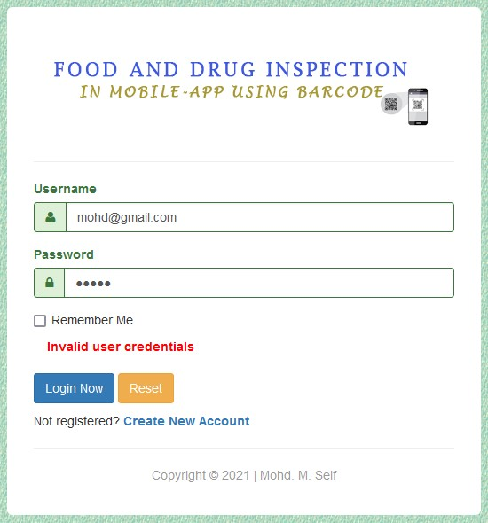

*Figure 13: Login Testing*

###### Changes Password

When a user submits a Password form with blank field the system will not allow him/her to continue until he/she filled the blank field and screen will appear like this: -

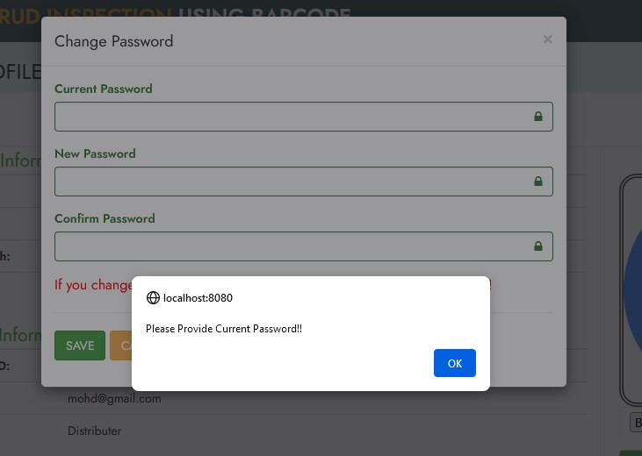

Figure 14: Change Password

### 5.4 User Interfaces

Is an interface where a user interacts with the website they’re using. It provides a pictorial representation of most important user interfaces of the main functionalities of the system.

###### When the User login in the System

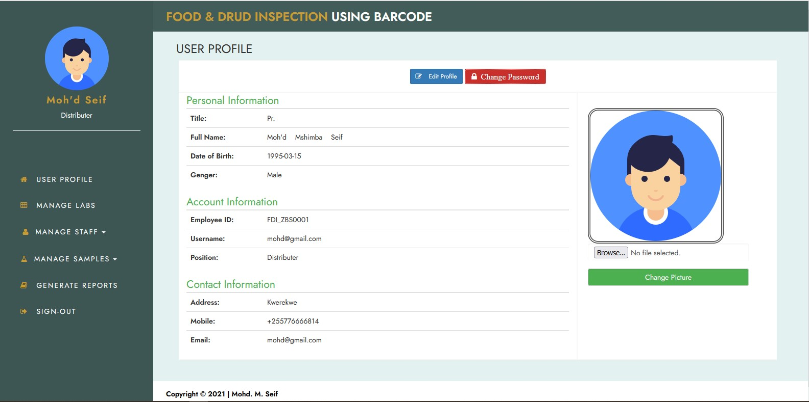

*Figure 15: User login*

###### Manage Laboratory

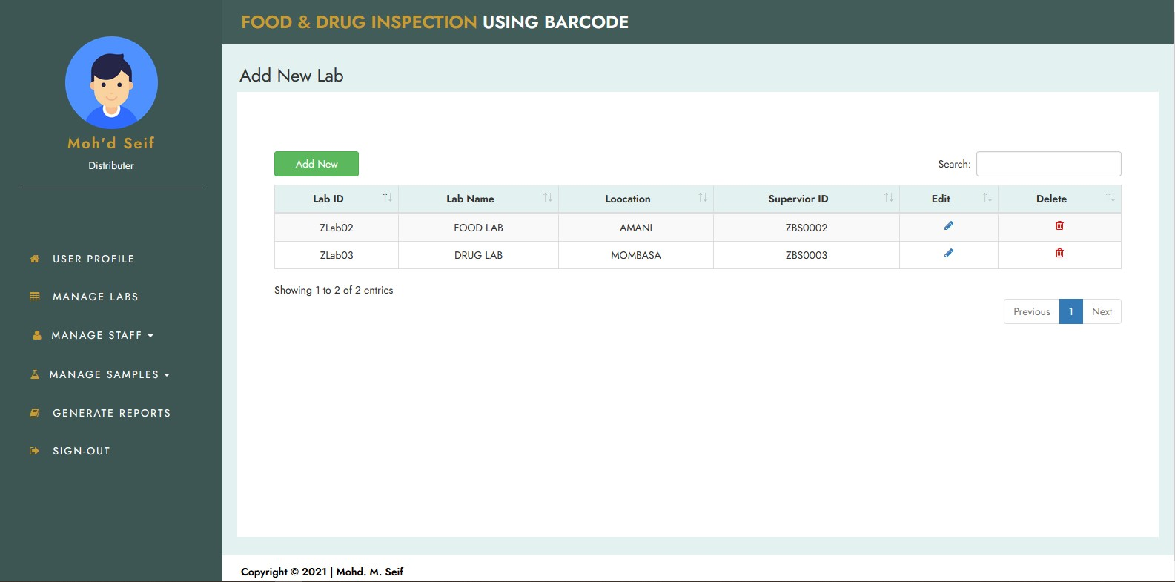

*Figure 16: Manage Laboratory*

###### Product Sample Records

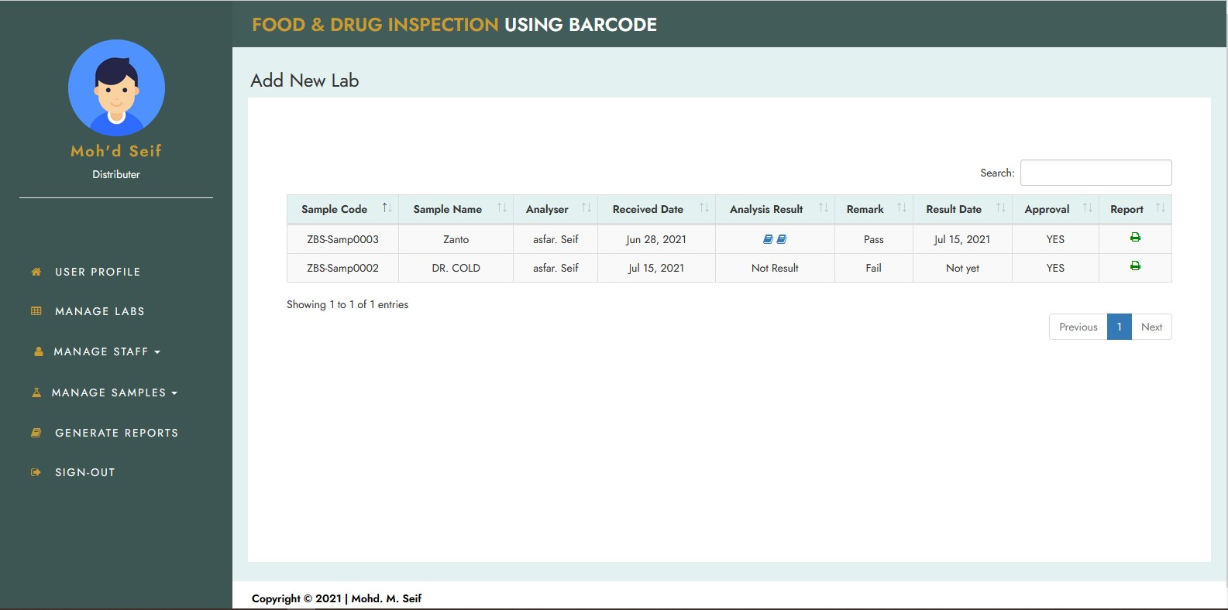

*Figure 17: Sample Records*

###### Register User from the system

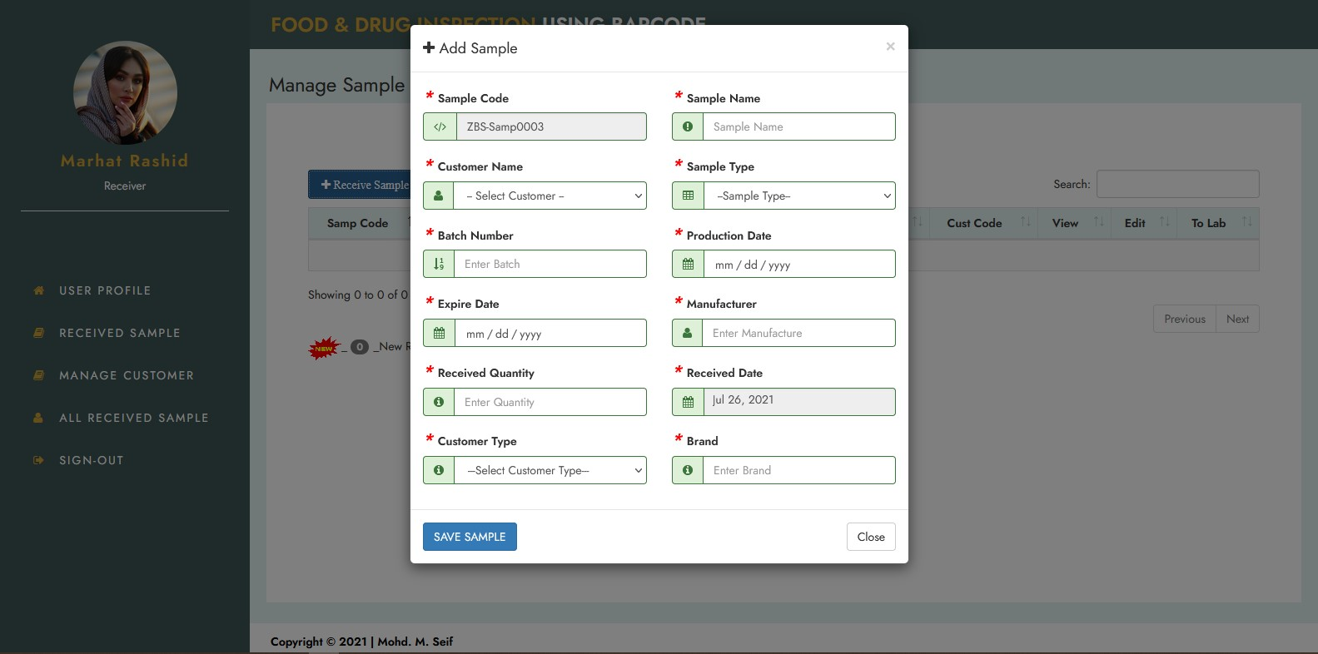

Figure 18: Register User from

**General Report**

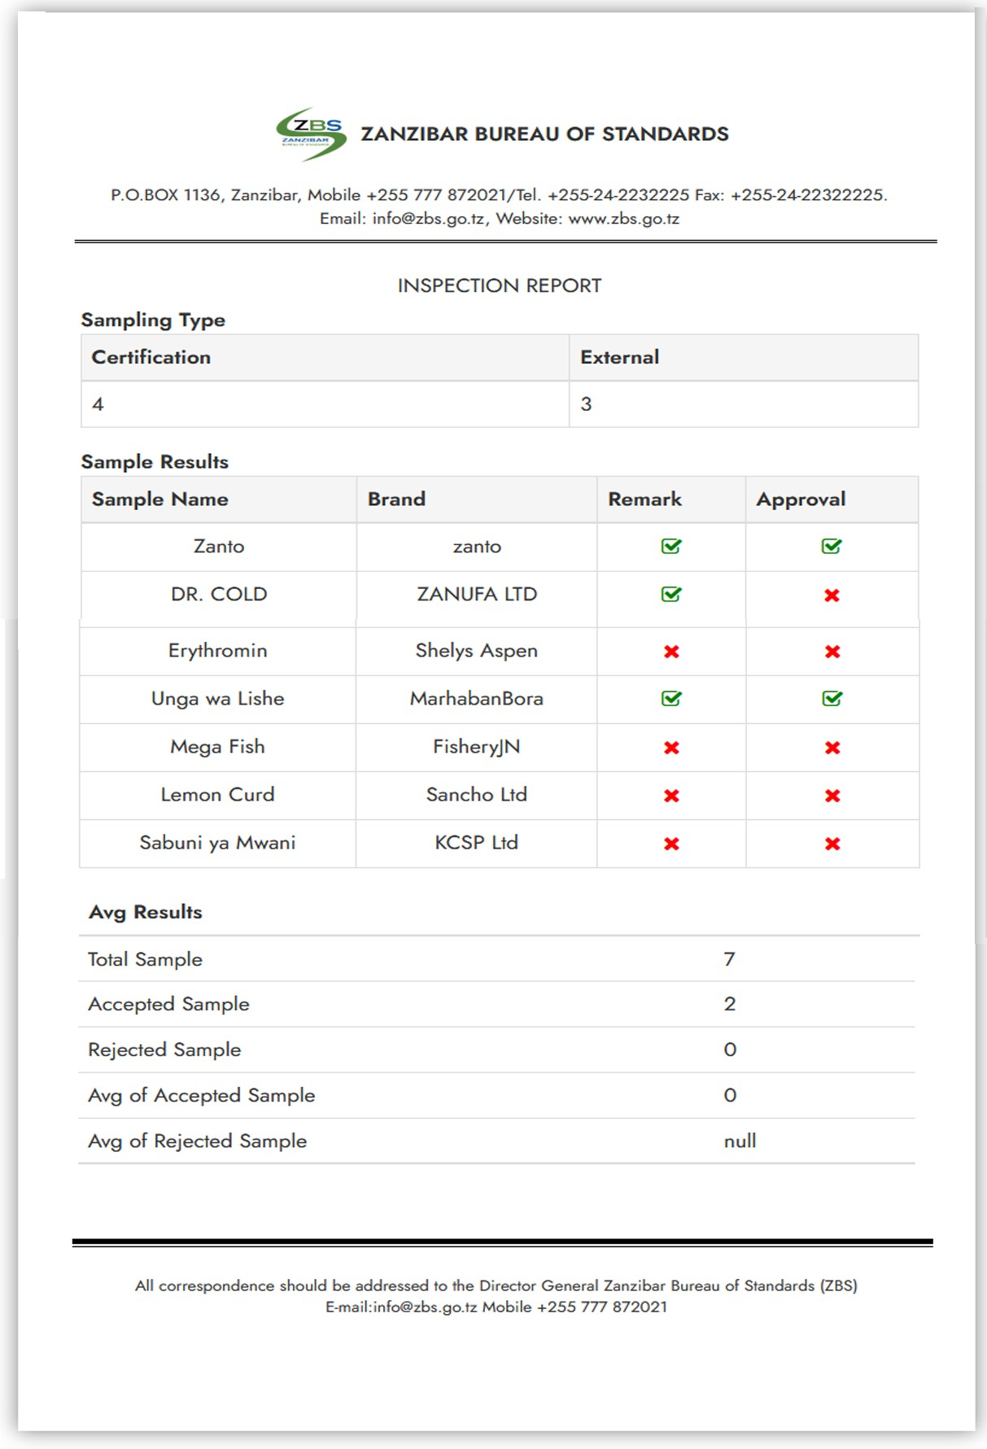

*Figure 19:General Report*

**Scanner Input of Product**

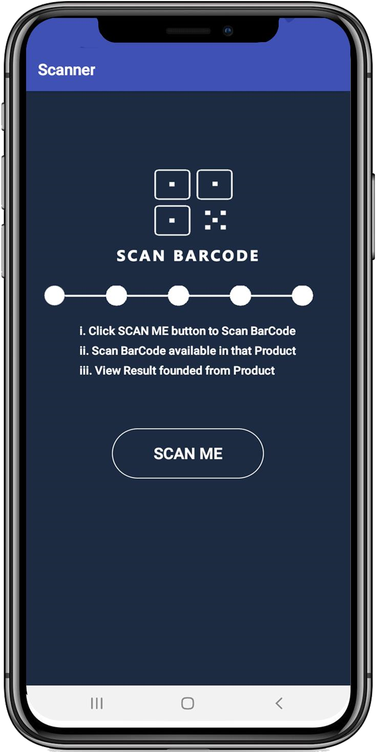

*Figure 20: Scanner Input*

###### Scanner output of Product

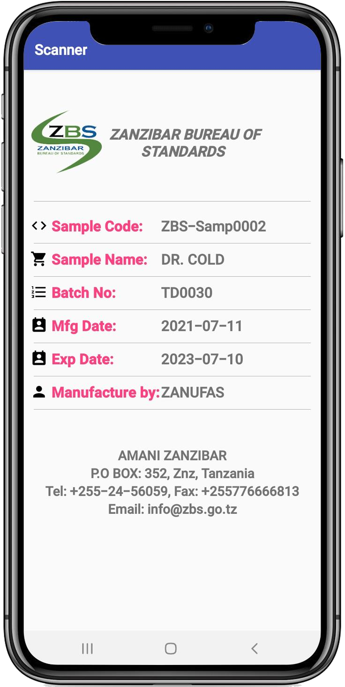

Figure 21: Scanner output

### 5.5 Strength ad Limitation of the system

5.5.1 What is covered from requirements

In this project we cover most of the requirement as mentioned above include functional requirements and non-functional requirements.

5.5.2 What is not covered

I just not cover Customer or the client cannot get his or her response via notifications on his or her phone after his or her application has been approved or rejected.

# CHAPTER 6: CONCLUSION, RECOMMENDATIONS AND CHALLENGES

Conclusion

Food and Drug Inspection in MobileApp Using Barcode system can help most of people in the whole system to know when a product is manufactured and when it expires. But also, FDI has simplified the institution in all aspects of product testing and evaluation, as in the beginning all activities are done by manual.

Recommendations

I recommend the following to university and department as whole: -

 Teacher has to establish the project scenarios from the scratch to the working system as sample to show to the student and give them views on what is needed when attempting to do the project.

 The university does not have enough resources and facilities to help us in doing the project.

Therefore, the resources and facilities such as computer laboratory should be increased.

Challenges

Challenge in anything cannot be avoided, through this project I got some of challenges as follows: -

######  Lack of reviews for referencing

In some ways I faced problem of having documented materials relevant to Inspection Systems such as books and articles. Most of the relevant materials were available Online only in which it gets harder to reviews them at the time with no internet connections.

######  Financial Supporting

I have been experienced with financial problems across the project development for Learning a new language that makes me spend a lot of time online looking for a resource, so the financial cost for attaining internet bundles has become a big challenge for me., but also cost in delivery of System which is required to be in hard copy and soft copy whereby it cost a lot in terms of printing system documentation.

######  Error Debugging

Error Debugging especially on android part, is a big challenge since most of device that I used for running this technology are not meet requirement, it take a lot time to running an application.

# References

Pardigm, V. (2017, September 25). *Conceptual, Logical and Physical Data Model*.

Visual Paradgm. [https://cs.visual-paradigm.com/.](https://cs.visual-paradigm.com/)

Garry, B. Shelly and Harry J. Rosenblatt, Ninth Edition, *System Analysis and Design.* 9thed, United state: Nicole Pinard.

Sami, M. (2012, March 15). *Software Development Life Cycle Models and Methodologies*.

Mohamed Sami Personal Website – Software Engineering.

Valacich, J. S. & George, J. F (2017). *Modern System Analysis and Design.* United State of America: Pearson Education Inc.

Robin, N. (2000) *Learning PHP, MySQL, and JavaScript. Sebastopol,* California: O’Reilly Media.

*Zanzibar Bureau of Standards*, accessed 23 November 2020, <[http://www.zbs.go.tz/>](http://www.zbs.go.tz/) *Zanzibar Food and Drug Agency*, accessed 23 November 2020, [<zfda.go.tz/>](http://www.zfda.go.tz/) [https://melsatar.blog/2012/03/15/software-development-life-cycle-models-and-methodologies/.](https://melsatar.blog/2012/03/15/software-development-life-cycle-models-and-methodologies/) [http://jcsites.juniata.edu/faculty/rhodes/daq/metadata.htm.](http://jcsites.juniata.edu/faculty/rhodes/daq/metadata.htm)

<https://javatpoint.academia.edu/JavaTpointcom><https://www.roseindia.net/index.shtml>